WELCOME

Downingtown West High School Football Kick-off Dinner
March 15, 2016

The coaches and booster club would like to welcome you to the Annual Kick-off Dinner for the 2016 football season hosted by the Downingtown West High School Football Booster Club. D-West Booster Club is a registered non-profit volunteer organization of parents, coaches, players, alumni and friends dedicated to supporting and developing the best high school football program in the country. Our focus is to provide financial support to the program for activities, events, buses for football camp, supplemental equipment, pre-game varsity meals, post-game food for all teams and an end-of-the year banquet with gifts. These items are not covered by the school district.

Tonight, your son will receive the 2016 D-West football t-shirt, courtesy of the Booster Club, so that all will know that he is a D-West Football Player! To support these efforts and other D-West football needs we have several fundraisers such as Tag Days, Whippet Discount Cards, game program sales, retail sales at the games, a golf outing and other social events. Downingtown West High School Football Booster Club, Inc. is a registered 501(C) (3) charitable organization and as such any donations are deductible to the extent allowable by law. Another focus that we have is to have a little fun along the way as we watch our sons play D-West High School football!

We appreciate your participation in these fundraisers. As an interested party in your son’s high school football development you are automatically considered a member of the Booster Club. We would like to invite you to contribute your time and talent wherever and whenever you can. There is no fee and no task that can’t use another set of hands. “Many hands make light work.” We have included a list of areas (page 6) that require your help and a list of contacts if you have any questions, concerns or if you would like to volunteer. Your ideas are also greatly appreciated as we try to grow in sustainability from one year to the next. We are confident that you’ll find volunteering extremely satisfying and a fantastic way to get to know other football parents and players!

Please visit with parent volunteers and/or booster officers tonight for more information or to answer your questions while the boys receive their T-shirts. Attached is a description of the current planned events, fundraisers and tasks that are scheduled. Let us know if you can help in any way. No volunteer will ever be turned away!

Mailing Address ~ DWHS Football Boosters, PO Box 249 ~ Downingtown, PA 19335

Sincerely,
Meg Ciliberto, Co-President cilimeg@gmail.com (610-952-5315)
Fred Iannini, Co-President f_iannini@hotmail.com (610-416-6215)
Tim Glennon, Vice President
Maureen Zapf, Secretary
Dave Jorgensen, Treasurer

Mike Milano, Head coach mmilano@dasd.org (610-269-4400 x7574)

www.DWHSfootball.com
Visit our website for all information pertaining to
Football at Downingtown West High School!
Online, you can:
- Check out the schedule and scores, team rosters and staff
- See Important Dates
- Read articles from the press
- Learn about fundraising opportunities, including:
  - Golf Outing (buy sponsorships, register to play, buy dinner tickets),
  - Game day Program (purchase ad space),
  - Discount Whippet Card (business sign up to participate)
- Make donations to the Whippets
- Learn about Whippet Football history with photos and stories
- Contact anyone at the Booster Club
- Buy ads for Senior players, cheerleaders and band members
- Seniors can enter their bio for the game day program
- Families can purchase $5 shout outs
**** Very Important ****
Please register your son on our website at
http://www.dwhsfootball.com/2016
Email will be our main form of communication with you throughout the season.

Description of Football Booster Activities
- 50/50 Raffle – Raffle tickets are sold prior to half time at the Varsity home football games. Committee brings supplies, coordinates volunteers to sells tickets, announces winner.
- Banquet – The banquet is held at the end of the football season for all players, parents and family members (space permitting). Player gifts are given for each grade. Players attend free. Committee selects venue, menu, decorates venue, selects and orders player gifts, creates program for event.
- Class Reps (Team Mom) – Primary liaison between parents + booster club; communicates football program and booster club information to parents/players of your respective class. Examples: coordinate parents to bring food to your assigned team dinner night, solicit volunteers for various duties throughout season, first stop for questions + guidance related to the football program.
- Clothing Sales – clothing and other school spirit items are sold during the Varsity home games or as needed.
- Game Day Help – At each Varsity home game, booster members help set up the clothing table, man the clothing table, hang the Championship banners along the stadium fence, sell programs at the door, and sell 50-50 tickets. A sign-up Genius email will precede each game.
- Game Programs – Business and Parent ads are purchased before the beginning of August. The programs are updated weekly. Programs are sold at every Varsity home game. Committee solicits businesses for ads, coordinates with graphic designers for program layout, and sells programs at games.
- Golf Outing – Event held in June. Help needed the day of the event and beforehand to solicit businesses for sponsorships and donations for auction items.
- Kick-off Dinner – This event is an annual event held in March/April of the current year to introduce the program and schedule to players and parents for the new football season. Committee selects caterer and menu for event. Coordinates volunteers for dinner and brings supplies needed.
- Pre-Game Meals—Food and drink are provided to the players before Varsity games that are scheduled on a school day; this is usually immediately after school for both home and away games.
- Post Game Food - Freshmen Games – Food and drinks are provided after the game for the players, for away games (home games are followed by a team dinner). The food and drinks are distributed at the entrance to the school locker rooms at the home games and outside the buses for away games. Committee is given a budget to buy food and drinks are from the sports drink donation. Committee brings food and drinks to after games.
- Post Game Food - JV games – Food and drinks are provided after the game for the players, for both home and away games. The food and drinks are distributed at the entrance to the school locker rooms at the home games and outside the buses for away games. Committee is given a budget to buy food and drinks are from the sports drink donation. Committee brings food and drinks to games.
- Post Game Food - Varsity games – Food and drinks are provided for all players that suited for the game, both home and away. The food and drinks are distributed at the entrance to the school locker rooms at the home games and outside the buses for away games. Committee is given a budget to buy food and drinks are from the sports drink donation. Committee brings food and drinks to games.
- Shipp Camp Registration –Assist Coach Milano with paperwork that includes registration, parent permission form and emergency medical release. A few booster volunteers are also at the school the day the boys leave for camp to address any problems.
- Sports Drink Donations – Each player must donate once case of either Gatorade or PowerAde. Class reps collect these donations at the first team dinner that is hosted by that class. Donations are divided amongst each of the Post Game Food volunteers so that they can be distributed to players after their games.
- Summer 7vs7 Shoot-Out @ D-West – This event is sponsored and organized by Coach Milano. Approximately 15-20 teams attend, 9am to 3pm. The Committee prepares and sells lunch for approximately 600 players and fans.
- Tag Day – players are organized into groups to accept donations at 4 intersections in Downingtown, from 9am-3pm, 3 times a year. Chaperones supervise the boys at all times. Chair coordinates volunteer schedule, deliver supplies and signs to each intersection, get parent volunteers to chaperone and help count money.
- Team and Game Photographer – A photographer has been chosen for the year for home and away Varsity games, however, we need volunteers to assist with team pictures in August and to take photos at JV and Freshman games.
- Team Spirit Dinners – The Booster parents organize a team dinner the evening before Varsity games. Each class is assigned a specific date to provide volunteers and food/drink donations.
- Water Boys – This tradition was started in 2004. Four DYW and Marsh Creek football players are invited be the Water boys for every Varsity home game. A Booster coordinates for freshman player volunteers to be at each home game and supervises boys on the field.
- Website Development – Booster Club website development linked from the main dwhsfootball.com website. Assist in providing content for website.
- Whippet Card – This card is a physical discount card sold, by the players, to support the football team. Committee coordinates obtaining vendors for cards, having cards produced, delivering and tracking cards to players.

You’re invited to attend
the D-West Football Booster Meetings
As an interested party in your son’s high school football development you are automatically considered a member of the Booster Club. We would like to invite you to contribute your time and talent wherever and whenever you can. There is no fee and no task that can’t use another set of hands.
The Downingtown West Booster Club meetings are held the 1st Thursday of every month, 7-8:30pm at the high school, room 143 or at Milito’s Restaurante, Bar, Pizzeria (Downingtown). Come and hear what is happening for the 2016 football season! We would love to see you there and have you share your ideas and opinions to further grow and support this organization. The club supports the Freshmen, Junior Varsity and Varsity teams.
Check online for the 2016 Booster meeting dates!
Bring your Ideas!! Get Involved!! Volunteer!!

Booster Club Volunteer Positions – 2016
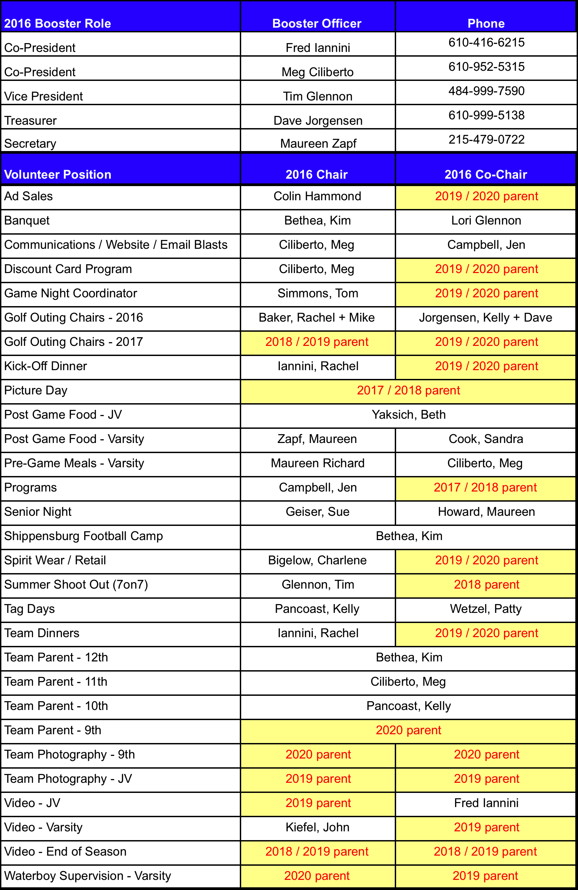
SPORTS DRINK DONATION
It is required that every player bring in One (1) Case (24 bottles of 20 ounces) of Gatorade or PowerAde to their first team sponsored dinner (dates to follow). Please place your last name on your case, along with your grade (Freshman, Sophomore, etc) and give to your Class Rep. This Gatorade/PowerAde will be used for Post Game Refreshment at Home and Away 9th grade, JV and Varsity games.

TEAM DINNERS
Chairperson: Rachel Iannini
Every week there is a dinner for the Downingtown West Football players, Cheerleaders and Coaches immediately following practice. Thursday, August 25th will be the first team dinner for our 2016 season. We will be contacting parents to volunteer food items, as parents are responsible for donating requested food/drinks during your grade’s assigned week. We will send a SignUp Genius email. Items should arrive between 5-5:30 pm in the cafeteria. Parents are invited to help set up, serve, and clean up. This is a fun way to spend time with the team!
The dinner dates are:
Thursday, September 1
Thursday, September 8
Thursday, September 15
Thursday, September 22
Thursday, September 29 (Homecoming parade – dinner will be a ‘to go’ meal)
Thursday, October 6
Thursday, October 13
Friday, October 21
Thursday, October 27

Please note that the cheerleaders bring complementary food.
As an example, the following is a list of the food and drinks we will need for our pasta dinners:
- 6 people are needed for – Meatballs, about 4 pounds in a crockpot (total 20-24 lbs)
- 6 people are needed for – Cooked Pasta with sauce, about 4 lbs in disposable pans (total 24 lbs)
- 5 people are needed for – Desserts (cookies, cupcakes, etc.)
- 5 people are needed for – Drinks ice tea, lemonade, or Gatorade (4 gallons from each person so total 20 gallons)
Other suggestions that may be considered in lieu of pasta may include: mac and cheese, taco bake, pulled pork, breakfast for dinner, etc.
Remember we are feeding approximately 160 HUNGRY Players, Cheerleaders, and Coaches AFTER PRACTICE each week. And we do not want to run out! THANK YOU!

Shipp Camp
Bus Permission Form

Team Camp Transportation
Fee: FREE - sponsored by DWHS Football Booster Club
Signed Forms due by June 3rd
Players cannot ride the bus without a Bus Permission Form
Please turn in the form with your Shipp registration.

I, ________________________________ the parent of _______________________________
(parent or guardian) (player's name)
give permission for my son to travel with the Downingtown West football
team on a coach bus to and from Shippensburg University camp on July 17 and July 21, 2016. I assume all responsibility and do hereby release, discharge and waive all
claims against the Downingtown Area School District and the Downingtown West
Football Booster Club, its officers and its members.
_______________________________________________ ______________________
(Parent’s Signature) (Date)

2016 Important Dates
Mark your Calendars!!

May 21 Tag Day #1 - - 9am-3pm

May 23- Jun 3 Spring Fling, Voluntary Football Drill
3:00 pm – 5:30 pm (except 5/27 + 5/30)

Jun 1 Valor Bowl at West Chester University Farrell Stadium

Jun 11 Tag Day #2 - - 9am-3pm

Jun 13-16 Future Whippets Camp
Suggested for incoming freshmen
Current players can fulfill graduation requirement by working (coaching) this camp (40 hours credit)

Jun 18 7 on 7 - Summer Shoot Out Tournament at DWHS
Boosters supply lunch for all teams & visitors

Jun 20 Golf Outing, BBQ and Silent Auction at Whitford Country Club
11:30 am Registration; 1:00 pm start; dinner following golf

Jun 25 7 on 7 at Souderton
Boosters supply lunch for team

Jul 21-24 Team Football Camp at Shippensburg University (Shipp)
Sophomore, Junior and Senior players
Boosters provide bus transportation + pizza on last day

Aug 8-12 Heat Acclimation Week

Aug 13 Tag Day #3 - - 9am-3pm

Aug 15 Start of Season — Two-a-days
See Coach Milano's calendar for times & dates

Sept, Oct, Nov 50/50 raffle sales, program sales, clothing/retail sales
All Varsity home games

Dec 4 Football Banquet
11am – 3pm at Technical College High School

Planning your Summer Vacation?
Players should NOT miss June 18, June 25 or July 21-24
What Does the Football Booster Club Provide?

Pre-game dinner on Varsity game days
Post-game food for our Freshmen, Junior Varsity and Varsity Teams
Team and Game photography
Website Development, email communications and updates
Kickoff Dinner and t-shirt for all players
Organize weekly team dinners in-season for all players (freshman included), coaches and cheerleaders (day before varsity game)
Coaches' clothing
SHIPP camp team transportation + last day pizza
Production & printing of Varsity home game day season programs
Varsity game day coordination (50/50 sales, program sales, water boy help)
Banquet -- players' & coaches’ tickets and season gifts
Equipment as needed (video cameras, video management system, iPad, weight room additions, etc)
Supplemental team training (yoga, strength & conditioning, etc)
Varsity Season Game Passes for freshman players
Other items/activities identified, as needed - approved by majority vote at the Booster meetings

**All donations are tax deductible to the extent allowable—Downingtown West High School Football Boosters Club, Inc. is a registered 501 (C) (3) non-profit organization

D-West Football Terminology

- “We put some hay in the barn today boys!” – Coach Carroll’s saying for getting a lot of work done at practice!
- “White-Out” – When we are the away team for the Battle of the Brandywine, everyone wears white. When we are the home team, we wear blue.
- 7 on 7 – A competition with other schools involving positions other than the offensive and defensive lines. This competition may be a practice or a tournament. This helps to review and practice plays.
- Battle of the Brandywine – The annual game between D-West vs. D-East.
- Boosters – All parents, family and friends of a D-West football player. You are automatically a Booster!
- Chesmont National League – Div AAAA, which consist of seven teams,
D-West, Avon Grove, D-East, Henderson, West Chester East, Coatesville, Bishop Shanahan.
- Coach’s Clothing Sale – Coach Milano sponsors a clothing sale in early spring.
- D-Dog – D-West’s mascot. D-Dog has a cute brown dog costume with a blue sweater. He’s the Whippets’ biggest fan!
- Film – A viewing of another team or of a particular home game for analysis.
- Melon Heads – Five bare-chested senior boys who wear a carved melon on their head to every home game. Each student paints a letter on their chest spelling out D-WEST. The melon head is a prestigious position. Senior melon heads pass on their “melon” to juniors to carry-on the tradition.

- Milano – Not to be confused with the Pepperidge Farm cookie - - Coach Mike Milano.
- Mitten Football – A game that the players love to play at the end of practice, gym and whenever they can! The ball can be advanced forward, backwards or sideways by passing or kicking to get to the end zone of a short field without being touched. Teams are usually 4-5 players.
- Season Passes – Check with the athletic department or at the gate. Senior Citizens have been free in past years.
- Shipp Camp – Annual summer camp to Shippensburg University for sophomores, juniors and seniors.
- Shout-Out Ads – Parents, friends or families can place a one-liner in the program for a small fee. The shout-out is encouraging and fun!
- Sponsors – Business or Parent sponsors who purchased an ad in our Football game program.
- Tailgating – All are invited to meet, greet and eat before the games. Parents, friends, families!
- Team Dinners – Dinner at School for freshmen, sophomore, junior, and senior players the evening before a varsity game, hosted by Boosters with volunteers and donations from each class as assigned.
- Water boys – DYW or Marsh Creek Eagle football players. Four boys per game.
- What? We share a stadium?! – We share Kottmeyer Stadium with D-East. We usually play on Friday night; D-East plays on Saturday night (or Fridays if we’re away).
Football Notes from

- Practices during the season run late due to reviewing film after practice. Check with your son to determine the specific days for offense vs. defense film review.

- All sophomore, junior and senior players attend the Shipp camp.
- Shipp Camp requires plain black shorts and white and gray t-shirts. Starts shopping early, stores have been known to run out just prior to camp.

- Shipp Camp — pack extra socks, Gatorade, baby powder and compression shorts. Electronics and other valuables should be left at home. Other schools share the dorms with our team.

- During 2-a-days camp in August, it is essential the boys stay hydrated and healthy. We will post meal tips on our website under “Health & Nutrition.”

- Freshman Games are usually Thursdays after school; JV games are usually Mondays after school; Varsity games are usually Friday evenings or Saturdays.

- When Varsity games fall on a school day, 10th-12th grade players are expected to remain at school. Pre-game dinner is provided by the Boosters.

- “Team Dinners” are after practice the day before a varsity game for all freshmen, sophomore, junior and senior players. The dinners are usually completed by 6:30pm.

- The “Pre-Game Meal” is served to the JV and Varsity players at school on game day, around 3pm, before every Varsity game, home or away. It is a specifically chosen healthy meal with emphasis on energy and nutrients.

Experienced Parents

- If there is a Friday varsity game there will be Saturday am film review for the JV and Varsity players 9-11:30am during the season.
- There will be practice over Labor Day weekend (Coach Milano determines day and time)

- ¼” cleats are most popular on turf. Some players interchange with other cleat sizes due to weather. Coach STRONGLY prefers the team to wear black or mostly black cleats. With an emphasis on mostly.

- The Freshmen team does not play their home games in Kottmeyer stadium. They play on the grass field near the middle school parking lot.

- JV home games are played on both the grass field near the middle school parking lot and in the stadium. Check the website prior to the home game.

- Varsity games are played in the stadium.

- The offensive and defensive lines do not compete in 7 on 7s.

- You can be a spectator at the 7 on 7s.

- Pack large lunches and snacks for in-season school days. Your player may snack throughout the day.

- The whiteboard in Coach Milano’s room must be used to notify the coaches as to when the player will not be at practice. This policy starts now.

- HAVE SOME FUN! GET INVOLVED!

